**Advance Excel Assignment 11**

1. Find the Minimum Marks and Maximum marks scored by each student from the below data.

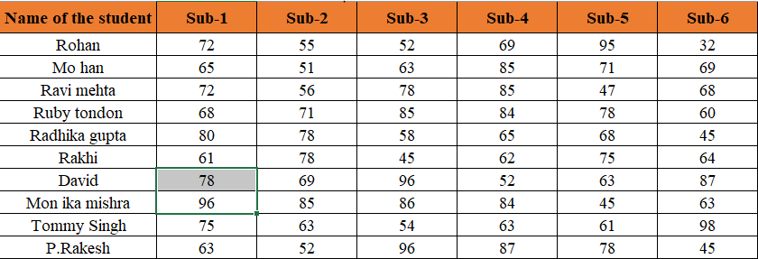

Ans.

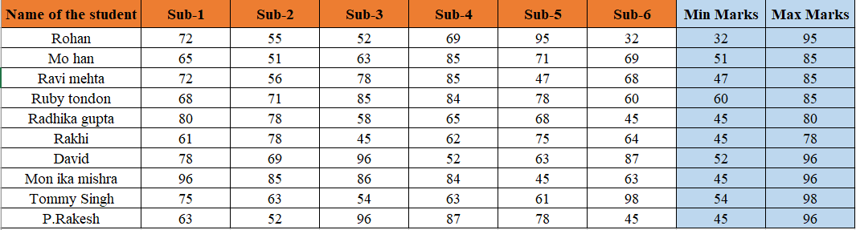

1. Calculate the totals for each student, use conditional formatting to highlight the top students who have scored more than 480.

Ans. No one has scored more than 480 marks.

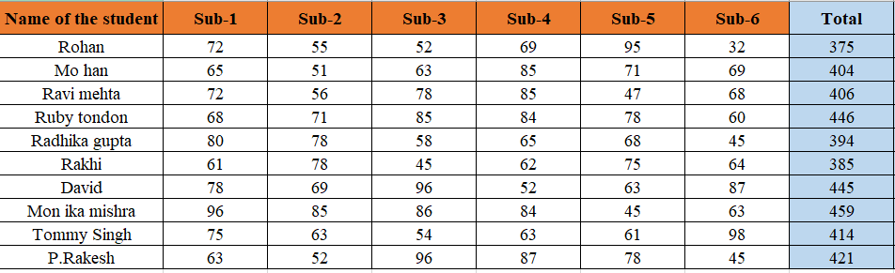

1. Calculate the length of the names of each student.

Ans.

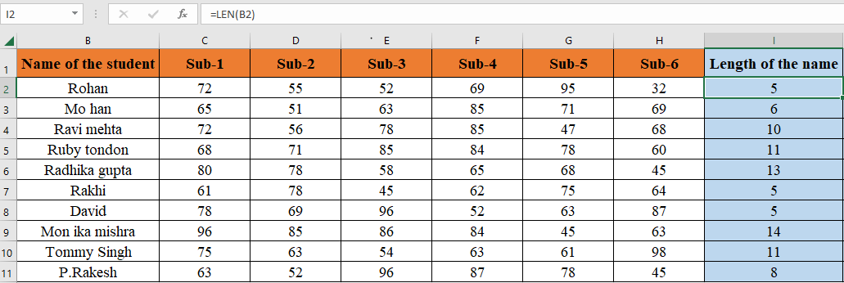

1. Replace the Name Rakhi with Rocky. Use Formulas

Ans.

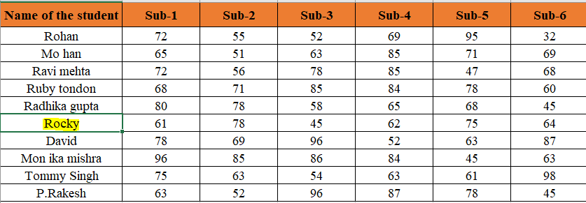

1. Combine the Roll Numbers and Names. Use formulas. The end result should look like below.

100101Rohan

Ans.

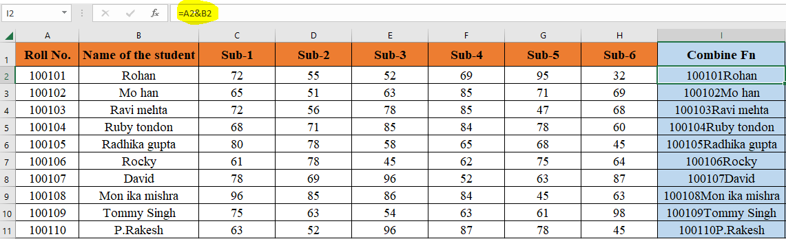

1. As you can see that some names have spacing issues. Use Formulas to correct that spacing. Also ensure that the names and surnames start with a capital letter.

Ans.

